CP – Lab
BSCS [1]

FINAL TERM PROJECT REPORT



Submitted By [Group No. 1]:

- Muhammad Haris Yasir (03-134212-062) (Leader)
- Muhammad Umar Tariq (03-134212-075)

Submitted to: Sir Asad Kamal

Date: 27 / 1 / 22

PROJECT NAME
Cheetay App

DEPARTMENT OF COMPUTER SCIENCES
BAHRIA UNIVERSITY, LAHORE CAMPUS

Table of Contents
Marks Distribution 3
Abstract 4
1. Introduction 4
2. Problem Statement 5
3. Objectives 5
4. Results 6
5. Manual 6
6. Code 12
7. References 43

Marks Distribution
------------------------------ For Instructor Use Only ----------------------------------
Project Grading Sheet
Sr. No. | Task | Max Marks | Obtained Marks | Comments(if any)
1. | Report | 2.5 | 2
2. | Implementation | 12.5 | 12
3. | Viva  (Oral/Task Based or Both) | 5 | 5
Total |  | 20 | 19 | Signature:
---------------------------------------------------------------------------

Abstract

Our Project name is Cheetay app. As you know that the cheetay app is the Grocery and Food store, so our project is to build an app in which different restaurants are shown to the us and what food they want to sell on restaurant. A user come on this and choose restaurant first and then he selects what he wants to eat. After this a type of bill will appeared which shows the total amount, delivery fee and much more. In the end the user give rating.
We built this project in a very simple way. We use structures, functions, and array to get the best result. It is important to that function calls which is user trying to get their product. We used arrays to the product name that user want to get.
Overall, in this assignment the user gets their product easily and not other products are shown which user would think to search just those products are shown which they want to get.

Introduction

This project is “Cheetay App” which is an online food ordering app. Basically, through this application you can order online almost any type of food describe in it. This is the basic fact and purpose of this app.
The importance of this application is you can easily order any type of food item by sitting in your house without going outside or anywhere. Using your phone or other device connected to internet. Your order will be at your door soon.
The motivation of doing this project is gain, by knowing that are almost everything which you can order online like buying products through Daraz App, booking vehicles ride like Uber, Careem and many more applications are in demand. So, we thought to make food application. It is very important for the industry because as you know it is very hard to say that; perhaps there is place in this world where food business isn’t working. This aspect also motivates us to food business. As advancement is increasing rapidly makes today’s life very hustle and bustle, so people can order any food using this application without going out, it will provide comfort and save travelling time. Now, people using this application instead of cooking in homes and going out, when they have less time, or they are fatigued, or they are having any functions or festivals. This made our application in demand in the market and ease to our customers.

Problem Statement

Problems:
The problem faced in this project are:
- First, we faced a problem that our restaurant and deals in each restaurant are collapsing and not working in proper way. Even are not in a proper format.
- Second, problem is to store the data like making records and receipts.
- Third, problem making shapes of the food items and logo.

Solutions:

Solutions of this problems are:
- Frist problem: We resolved this issue by making different functions respect to our restaurants and then call the particular restaurant which the user want. And divide the deals of that restaurants in decision structure.

- Second problem: We resolved this issue by creating files and store the records and receipts of order in the files. Basically, we used file handling.

- Third problem: This issue was not a big deal although it was very time consuming simply done by manipulator operators.

Objectives

Our aim in this project was to built app like Cheetay app. Our main objective is to get the user that specific category which he wants to open and get the pricing details of all the product which are given are to calculate it and then get the final receipt of the product that user want to buy. We built minimum four restaurants in which all the products are being written and give one restaurant to all our group participants to mange it. Now we want what the syntax we used to get products. So, we used arrays and function the main thing easier to make our project. We also used a structure of restaurant. As the user select which restaurant, he would select to open so we used structure so his name of the restaurant pass with that restaurant which we will given and then just that restaurant products are appear to the user.

Results

The method that we adopt in this project is mainly parallel arrays. A user search a product and we write product name in one array and their prices are written in the second array. So, when the user search something these arrays work parallelly and his price will give according to the parallel sequence. Then we pass their name and price into another function which will work as Add to Cart option. In it the user sees her restaurant name which he selected firstly and see their receipt in which how many products he brought total price was also written there. So, this is the final output that the user sees, and their order is now confirmed.

Manual
0.
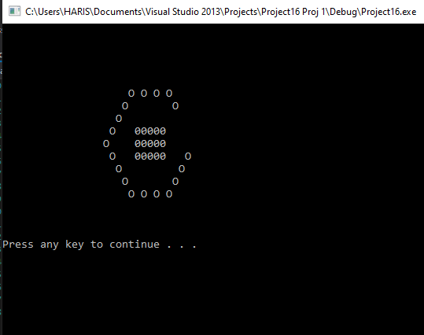

1. 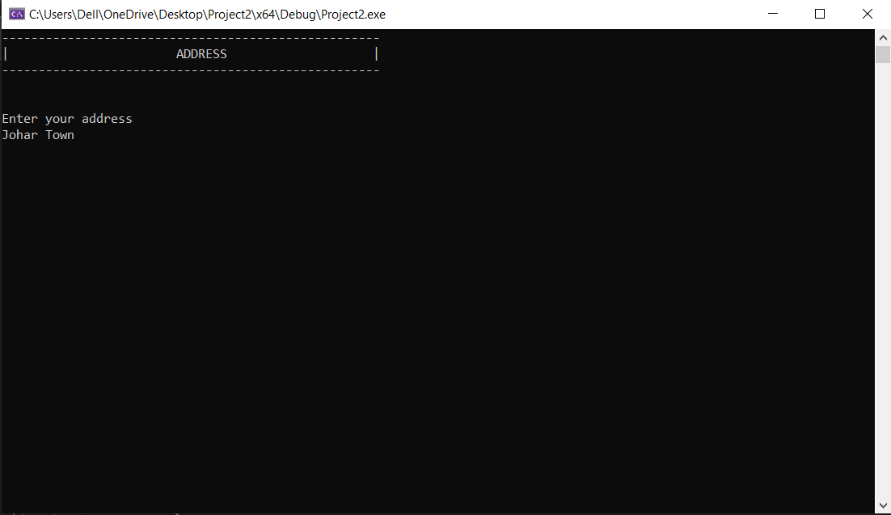

2.
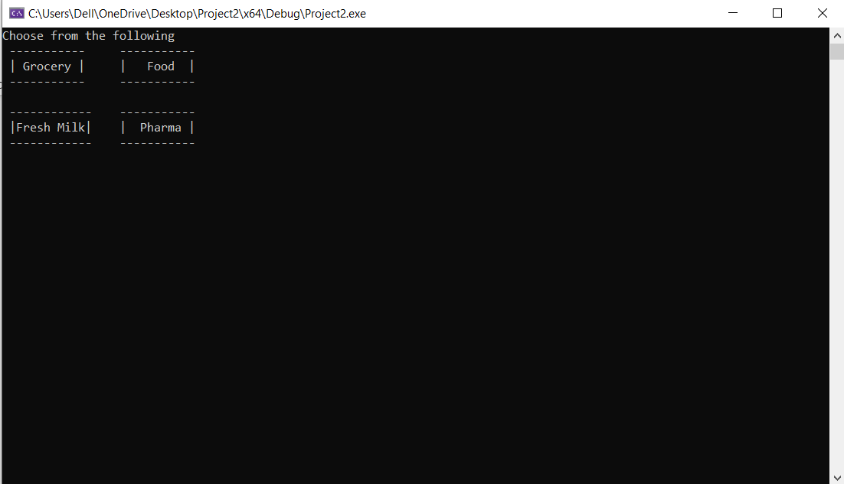

3.
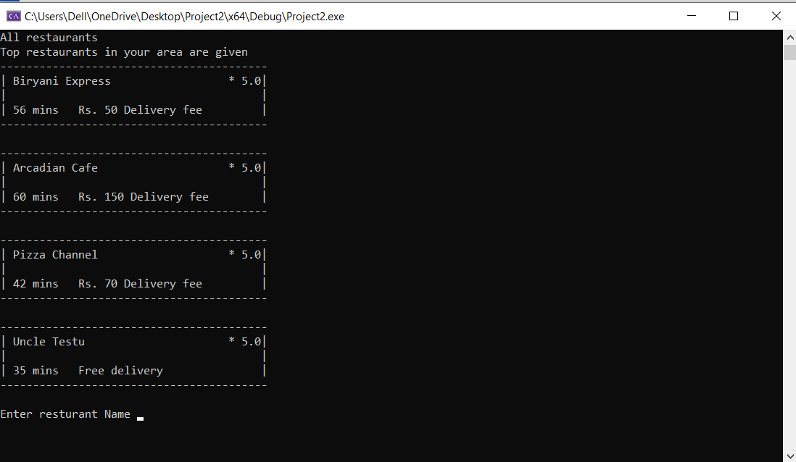

4.
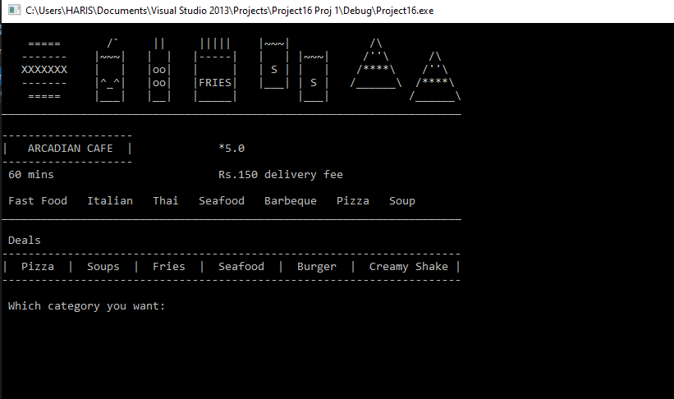

5.
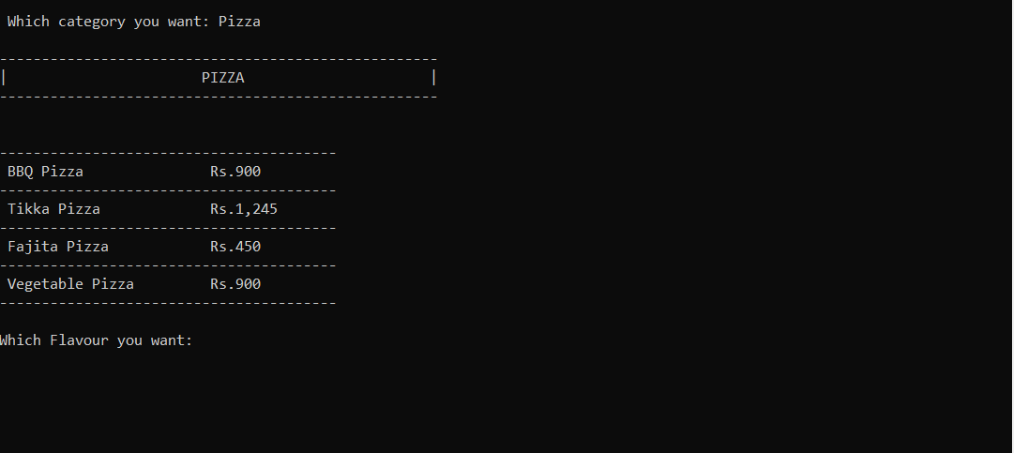

6.
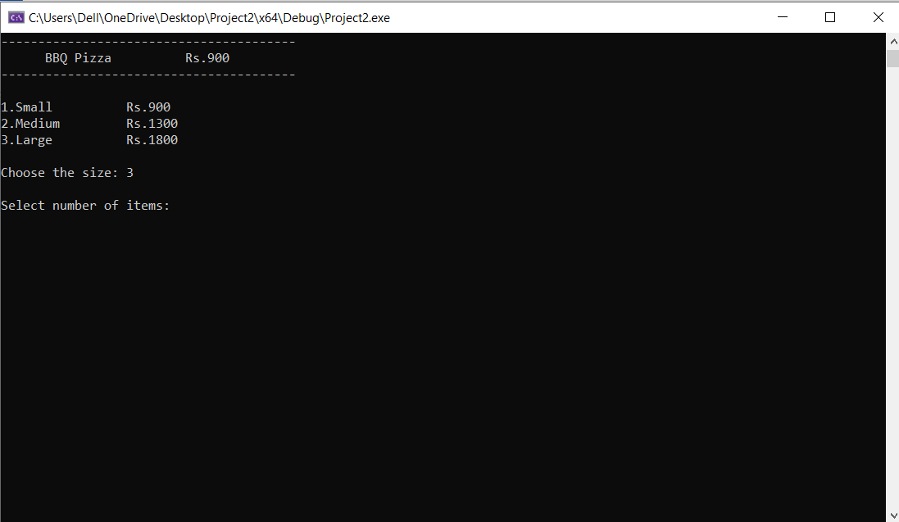

7.
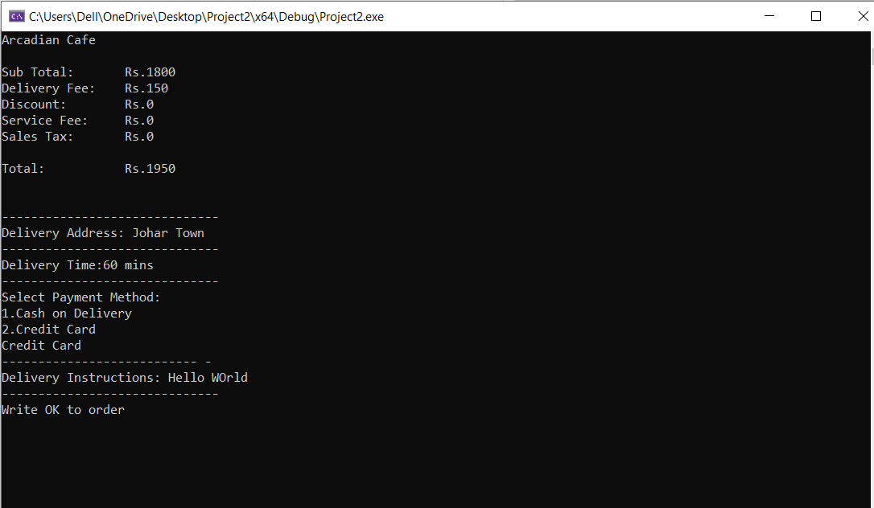

8.
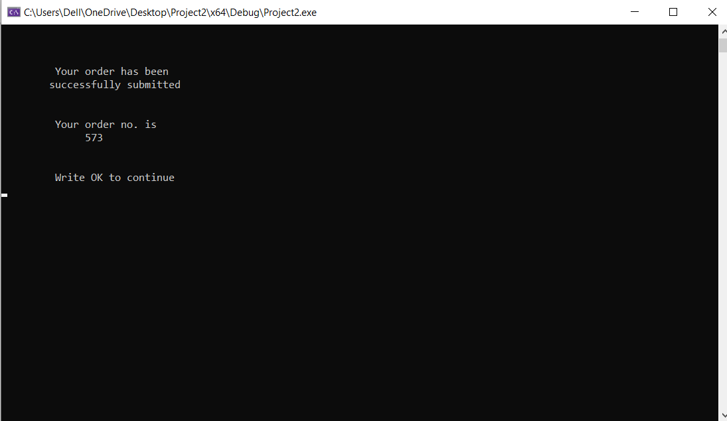

9.
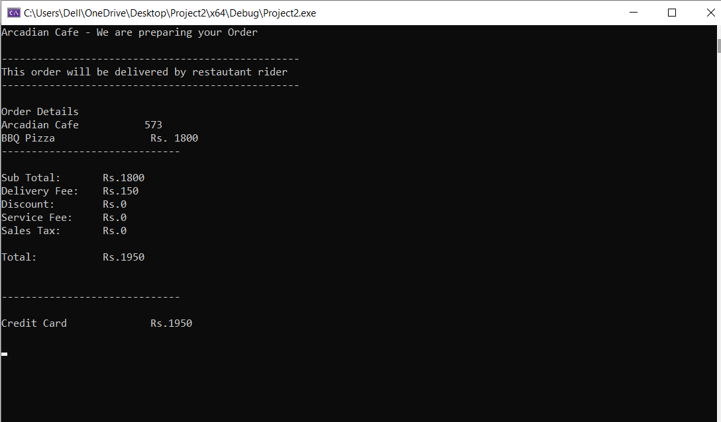

10.
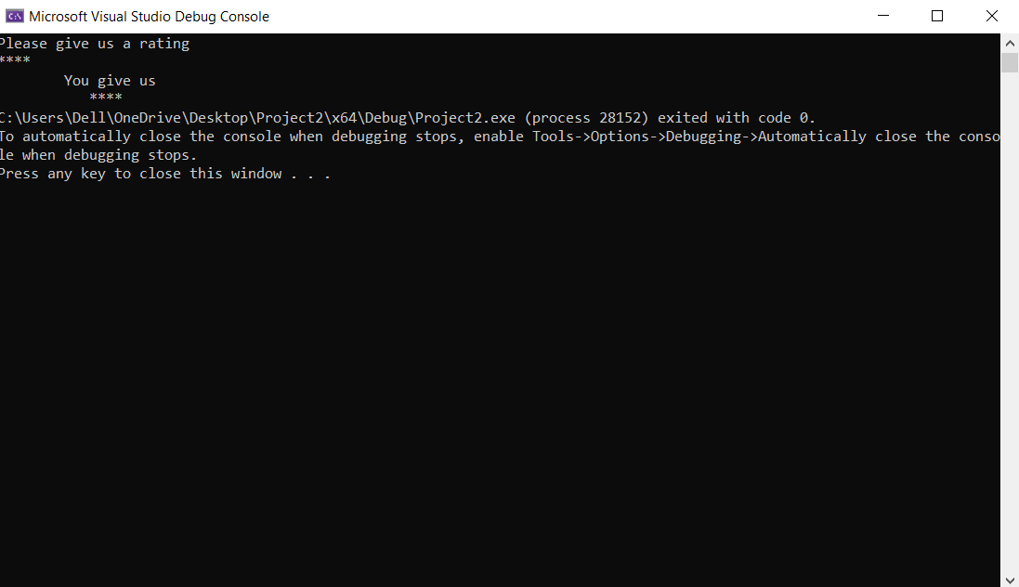

Code
#include<iostream>
#include<windows.h>
#include<fstream>
#include<iomanip>
#include<string>
#include<ctime>

using namespace std;

void show_menue();
void Food();
void BiryaniExpress();
void Arcadian_Cafe();
void Pizza_Chaneel();
void Uncle_Tesu();
void cart(int a,string b);
int g;

struct resturant
{
string restname;
int DeliFee;
int DeliTime;
string address;
}s;

int main()
{
/*HANDLE h = GetStdHandle(STD_OUTPUT_HANDLE);
SetConsoleTextAttribute(h,4 );*/
system("color 6");
cout << "\n\n\n\n\n\n";
cout << setw(10) << setfill(' ') << " " << "O O O O O O OOOOOOO OOOOOOO OOOOOOOO OOOOOOOOOOO O O\n";
cout << setw(9) << setfill(' ') << " " << "O O O O O O O O O O O\n";
cout << setw(8) << setfill(' ') << " " << "O O O O O O O O O O \n";
cout << setw(7) << setfill(' ') << " " << "O 00000 O O O O O O O O O\n";
cout << setw(6) << setfill(' ') << " " << "O 00000 OOOOOOO OOOOOOO OOOOOOO OOOOOOOOOO O O\n";
cout << setw(7) << setfill(' ') << " " << "O 00000 O O O O O O O O O\n";
cout << setw(8) << setfill(' ') << " " << "O O O O O O O O O O\n";
cout << setw(9) << setfill(' ') << " " << "O O O O O O O O O O\n";
cout << setw(10) << setfill(' ') << " " << "O O O O O O OOOOOOO OOOOOOO O O O O\n";
cout << "\n\n\n\n\n\n";

string choice;
cout << setw(52) << setfill('-') << "-" << endl;
cout << "|" << setw(23) << setfill(' ') << " " << "ADDRESS" << setw(20) << setfill(' ') << " " << "|" << endl;
cout << setw(52) << setfill('-') << "-" << endl << endl << endl;
cout << "Enter your address\n";
getline(cin, s.address);

show_menue();
cin >> choice;
if (choice == "Food")
{
Food();
}
else
{
cout << "Invalid Input";
}
}

void Food()
{
string resturants;
system("cls");
cout << "All restaurants\n";
cout << "Top restaurants in your area are given\n";

cout << setw(41) << setfill('-') << "-" << endl;
cout << "| " << "Biryani Express" << setw(18) << setfill(' ') << " " << "* 5.0|" << endl;
cout << "|" << setw(39) << setfill(' ') << " " << "|\n";
cout << "| " << " 60 mins" << " " << "Rs. 150 Delivery fee" << setw(7) << setfill(' ') << " " << "|\n";
cout << setw(41) << setfill('-') << "-" << "\n\n";

cout << setw(41) << setfill('-') << "-" << endl;
cout << "| " << "Arcadian Cafe" << setw(20) << setfill(' ') << " " << "* 5.0|" << endl;
cout << "|" << setw(39) << setfill(' ') << " " << "|\n";
cout << "| " << "60 mins" << " " << "Rs. 150 Delivery fee" << setw(8) << setfill(' ') << " " << "|\n";
cout << setw(41) << setfill('-') << "-" << "\n\n";

cout << setw(41) << setfill('-') << "-" << endl;
cout << "| " << "Pizza Channel " << setw(19) << setfill(' ') << " " << "* 5.0|" << endl;
cout << "|" << setw(39) << setfill(' ') << " " << "|\n";
cout << "| " << "30 mins" << " " << "Rs. 120 Delivery fee" << setw(8) << setfill(' ') << " " << "|\n";
cout << setw(41) << setfill('-') << "-" << "\n\n";

cout << setw(41) << setfill('-') << "-" << endl;
cout << "| " << "Uncle Testu" << setw(22) << setfill(' ') << " " << "* 5.0|" << endl;
cout << "|" << setw(39) << setfill(' ') << " " << "|\n";
cout << "| " << "40 mins" << " " << "Rs. 70 Delivery fee" << setw(9) << setfill(' ') << " " << "|\n";
cout << setw(41) << setfill('-') << "-" << "\n\n";

cin.ignore();
cout << "Enter resturant Name ";
getline(cin, s.restname);
if (s.restname == "Biryani Express")
{
BiryaniExpress();
}
else if (s.restname == "Arcadian Cafe")
{
Arcadian_Cafe();
}
else if (s.restname == "Pizza Channel")
{
Pizza_Chaneel();
}
else if (s.restname == "Uncle Testu")
{
Uncle_Tesu();
}
else
cout << "Invalid input";
}

void show_menue()
{
system("cls");
cout << "Choose from the following\n";
cout << " " << setw(11) << setfill('-') << "-" << setw(5) << setfill(' ') << " " << setw(11) << setfill('-') << "-" << endl;
cout << " " << "| " << "Grocery |" << " " << "| " << "Food" << " |\n";
cout << " " << setw(11) << setfill('-') << "-" << setw(5) << setfill(' ') << " " << setw(11) << setfill('-') << "-" << "\n\n";
cout << " " << setw(12) << setfill('-') << "-" << setw(4) << setfill(' ') << " " << setw(11) << setfill('-') << "-" << endl;
cout << " " << "|" << "Fresh Milk|" << " " << "| " << "Pharma" << " |\n";
cout << " " << setw(12) << setfill('-') << "-" << setw(4) << setfill(' ') << " " << setw(11) << setfill('-') << "-" << endl;
}

void BiryaniExpress()
{
string cho, c, d,m;
int e, f;
s.DeliFee = 150;
s.DeliTime = 60;
system("CLS");
cout << endl; // Shapes
cout << setw(9) << "=====" << setw(9) << "/`" << setw(7) << "||" << setw(10) << "|||||" << setw(9) << "|~|" << setw(14) << "/\\" << endl;
cout << setw(10) << "-------" << setw(9) << "|~|" << setw(7) << "| |" << setw(10) << "|-----|" << setw(8) << "| |" << setw(6) << "|~|" << setw(9) << "/''\\" << setw(8) << "/\\" << endl;
cout << setw(10) << "XXXXXXX" << setw(9) << "| |" << setw(7) << "|oo|" << setw(10) << "| |" << setw(8) << "| S |" << setw(6) << "| |" << setw(10) << "/**\\" << setw(8) << "/''\\" << endl;
cout << setw(10) << "-------" << setw(9) << "|^^|" << setw(7) << "|oo|" << setw(10) << "|FRIES|" << setw(8) << "|_|" << setw(6) << "| S |" << setw(11) << "/___\\" << setw(8) << "/**\\" << endl;
cout << setw(9) << "=====" << setw(10) << "|_|" << setw(7) << "|_|" << setw(10) << "|_|" << setw(14) << "|_|" << setw(20) << "/___\\" << endl;
//cout << setw(70) << setfill('') << "" << endl << endl;
cout << s.restname<<"\t\t *5.0" << endl <<s.DeliTime<< " mins \t\t Rs."<< s.DeliFee<<" delivery fee \n\n";
cout << setw(70) << setfill('_') << "_" << endl << endl;
cout << " Deals \n\n";
cout << " Biryani Soups Fries Burgers Sandwiche \n\n";
cout << setw(70) << setfill('_') << "_" << endl << endl;
cout << " Which category you want: ";
getline(cin, cho);
cout << endl;
if (cho == "Biryani")
{
cout << setw(52) << setfill('-') << "-" << endl;
cout << "|" << setw(23) << setfill(' ') << " " << "BIRYANI" << setw(20) << setfill(' ') << " " << "|" << endl;
cout << setw(52) << setfill('-') << "-" << endl << endl << endl;
cout << "Chicken Biryani\t\tRs.169\nBBQ Biryani\t\tRs.399\nDelight Biryani\t\tRs.390\nChicken Biryani Combo\tRs.259\n";
string a[] = { "Chicken Biryani", "BBQ Biryani", "Delight Biryani", "Chicken Biryani Combo" };
int b[] = { 169, 399, 390, 259 };
getline(cin, c);
for (int i = 0; i < 4; i++)
{
if (c == a[i])
{
system("cls");
m = a[i];
cout << m;
cout << "\t\t" << b[i];
cout <<endl<< setw(30) << setfill('_') << '_' << endl;
cout << "\nChoose your size: \n";
cout << "1.Half \t" << "\n2.Medium \t +Rs. 150 \n";
cin >> d;
if (d == "1")
{
e = b[i];
cout << setw(30) << setfill('_') << '_' << endl;
cout << "Select number of items: ";
cin >> f;
g = e * f;
cout << g << "\n";
cart(g,m);
}
else if (d == "2")
{
e = b[i] + 150;
cout << setw(30) << setfill('_') << '_' << endl;
cout << "Select number of items: ";
cin >> f;
g = e * f;
cout << g << "\n";
cart(g,m);
}
}
}
}
else if (cho == "Soups")
{
cout << setw(52) << setfill('-') << "-" << endl;
cout << "|" << setw(23) << setfill(' ') << " " << "SOUPS" << setw(22) << setfill(' ') << " " << "|" << endl;
cout << setw(52) << setfill('-') << "-" << endl << endl << endl;
cout << "Special Soup\t\tRs. 245\nHot N Sour Soup\t\tRs. 200\nChicken Corn Soup\tRs. 190\nThai Soup\t\tRs. 220\n\n";
string a[] = { "Special Soup", "Hot N Sour Soup", "Chicken Corn Soup", "Thai Soup" };
int b[] = { 245, 200, 190, 220 };
getline(cin, c);
for (int i = 0; i < 4; i++)
{
if (c == a[i])
{
system("cls");
m = a[i];
cout << m;
cout << "\t\t" << b[i];
cout << endl << setw(30) << setfill('_') << '_' << endl;
cout << "\nChoose your size: \n";
cout << "1.Single Bowl \t" << "\n2.Family Bowl \t +Rs. 500\n ";
cin >> d;
if (d == "1")
{
e = b[i];
cout << setw(30) << setfill('_') << '_' << endl;
cout << "Select number of items: ";
cin >> f;
g = e * f;
cout << g << "\n";
cart(g,m);
}
else if (d == "2")
{
e = b[i] + 500;
cout << setw(30) << setfill('_') << '_' << endl;
cout << "Select number of items: ";
cin >> f;
g = e * f;
cout << g << "\n";
cart(g,m);
}
}
}
}
else if (cho == "Fries")
{
cout << setw(52) << setfill('-') << "-" << endl;
cout << "|" << setw(23) << setfill(' ') << " " << "FRIES" << setw(22) << setfill(' ') << " " << "|" << endl;
cout << setw(52) << setfill('-') << "-" << endl << endl << endl;
cout << "French Fries\tRs. 220\nMayo Fries\tRs. 313\nMasala Fries\tRs. 254\nBBQ Fries\tRs. 313\n";
string a[] = { "French Fries", "Mayo Fries", "Masala Fries", "BBQ Fries" };
int b[] = { 220, 313, 254, 313 };
getline(cin, c);
for (int i = 0; i < 4; i++)
{
if (c == a[i])
{
system("cls");
m = a[i];
cout << m;
cout << "\t" << b[i];
e = b[i];
g = e;
cout << g << "\n";
cart(g,m);

}
}
}
else if (cho == "Burgers")
{
cout << setw(52) << setfill('-') << "-" << endl;
cout << "|" << setw(23) << setfill(' ') << " " << "BURGERS" << setw(20) << setfill(' ') << " " << "|" << endl;
cout << setw(52) << setfill('-') << "-" << endl << endl << endl;
cout << "Beef Burger\t\tRs. 279\nChicken Burger\t\tRs. 271\nMalik Burger\t\tRs. 322\nGrilled Breast Burger\tRs. 305\n";
string a[] = { "Beef Burger", "Chicken Burger", "Malik Burger", "Grilled Breast Burger" };
int b[] = { 279, 271, 322, 305 };
getline(cin, c);
for (int i = 0; i < 4; i++)
{
if (c == a[i])
{
system("cls");
m = a[i];
cout <<m<< "\t" << b[i];
cout << endl << setw(30) << setfill('_') << '_' << endl;
cout << "\nChoose your size: \n";
cout << "1.Nothing\n" << "2.Extra Cheese \t +Rs. 89" << "\n3.Coleslaw \t +Rs. 89\n" << "4.Both\n";
cin >> d;
if (d == "1")
{
e = b[i];
cout << setw(30) << setfill('_') << '_' << endl;
cout << "Select number of items: ";
cin >> f;
g = e * f;
cout << g << "\n";
cart(g,m);
}
if (d == "2")
{
e = b[i] + 89;
cout << setw(30) << setfill('_') << '_' << endl;
cout << "Select number of items: ";
cin >> f;
g = e * f;
cout << g << "\n";
cart(g,m);
}
else if (d == "3")
{
e = b[i] + 89;
cout << setw(30) << setfill('_') << '_' << endl;
cout << "Select number of items: ";
cin >> f;
g = e * f;
cout << g << "\n";
cart(g,m);
}
else if (d == "4")
{
e = b[i] + 89 + 89;
cout << setw(30) << setfill('_') << '_' << endl;
cout << "Select number of items: ";
cin >> f;
g = e * f;
cout << g << "\n";
cart(g,m);
}
}
}
}
else if (cho == "Sandwiche")
{
cout << setw(52) << setfill('-') << "-" << endl;
cout << "|" << setw(23) << setfill(' ') << " " << "Sandwiche" << setw(18) << setfill(' ') << " " << "|" << endl;
cout << setw(52) << setfill('-') << "-" << endl << endl << endl;
cout << "Chicken Sandwich\tRs. 271\nClub Sandwich\t\tRs. 200\nGrilled breast Sandwich\tRs. 288\nChicken Steak Sandwich\tRs. 296\n\n";
string a[] = { "Chicken Sandwich", "Club Sandwich", "Grilled breast Sandwich", "Chicken Steak Sandwich" };
int b[] = { 271,200,288,296 };
getline(cin, c);
for (int i = 0; i < 4; i++)
{
if (c == a[i])
{
system("cls");
m = a[i];
cout<<m << "\t" << b[i];
cout << endl << setw(30) << setfill('_') << '_' << endl;
cout << "\nChoose your size: \n";
cout << "1.Nothing\n" << "2.Extra Cheese \t +Rs. 89" << "\n3.Coleslaw \t +Rs. 89\n" << "4.Both\n";
cin >> d;
if (d == "1")
{
e = b[i];
cout << setw(30) << setfill('_') << '_' << endl;
cout << "Select number of items: ";
cin >> f;
g = e * f;
cout << g << "\n";
cart(g,m);
}
else if (d == "2")
{
e = b[i] + 89;
cout << setw(30) << setfill('_') << '_' << endl;
cout << "Select number of items: ";
cin >> f;
g = e * f;
cout << g << "\n";
cart(g,m);
}
else if (d == "3")
{
e = b[i] + 89;
cout << setw(30) << setfill('_') << '_' << endl;
cout << "Select number of items: ";
cin >> f;
g = e * f;
cout << g << "\n";
cart(g,m);
}
else if (d == "4")
{
e = b[i] + 89 + 89;
cout << setw(30) << setfill('_') << '_' << endl;
cout << "Select number of items: ";
cin >> f;
g = e * f;
cout << g << "\n";
cart(g,m);
}
}
}
}
else
{
cout << "This item does not exist. \n";
}
}
void Arcadian_Cafe() //Arcadian Cafe
{
system("CLS");
string cho,c,m;
s.DeliFee = 150;
s.DeliTime = 60;
//system("color 7C");
cout << endl; // Shapes
cout << setw(9) << "=====" << setw(9) << "/`" << setw(7) << "||" << setw(10) << "|||||" << setw(9) << "|~|" << setw(14) << "/\\" << endl;
cout << setw(10) << "-------" << setw(9) << "|~|" << setw(7) << "| |" << setw(10) << "|-----|" << setw(8) << "| |" << setw(6) << "|~|" << setw(9) << "/''\\" << setw(8) << "/\\" << endl;
cout << setw(10) << "XXXXXXX" << setw(9) << "| |" << setw(7) << "|oo|" << setw(10) << "| |" << setw(8) << "| S |" << setw(6) << "| |" << setw(10) << "/**\\" << setw(8) << "/''\\" << endl;
cout << setw(10) << "-------" << setw(9) << "|^^|" << setw(7) << "|oo|" << setw(10) << "|FRIES|" << setw(8) << "|_|" << setw(6) << "| S |" << setw(11) << "/___\\" << setw(8) << "/**\\" << endl;
cout << setw(9) << "=====" << setw(10) << "|_|" << setw(7) << "|_|" << setw(10) << "|_|" << setw(14) << "|_|" << setw(20) << "/___\\" << endl;
cout << setw(70) << setfill('_') << '_' << endl << endl;
cout << setw(20) << setfill('-') << "-" << endl << "| "<<s.restname<<" | " << "\t\t * 5.0" << endl << setw(20) << setfill('-') << " - " << endl;
cout << s.DeliTime << " mins \t\t\t Rs."<< s.DeliFee<<" delivery fee \n\n";
cout << " Fast Food Italian Thai Seafood Barbeque Pizza Soup \n";
cout << setw(70) << setfill('_') << '_' << endl << endl;
cout << " Deals \n"; // Deals
cout << setw(70) << setfill('-') << "-" << endl;
cout << "| Pizza | Soups | Fries | Seafood | Burger | Creamy Shake | \n";
cout << setw(70) << setfill('-') << "-" << endl << endl; // Category
cout << " Which category you want: ";
getline(cin, cho);
cout << endl;
if (cho == "Pizza") // Pizza
{
cout << setw(52) << setfill('-') << "-" << endl;
cout << "|" << setw(23) << setfill(' ') << " " << "PIZZA" << setw(22) << setfill(' ') << " " << "|" << endl;
cout << setw(52) << setfill('-') << "-" << endl << endl << endl;
cout << setw(40) << setfill('-') << "-" << endl
<< " BBQ Pizza \t\t Rs.900 \n" << setw(40) << setfill('-') << "-" << endl
<< " Tikka Pizza \t\t Rs.1,245 \n" << setw(40) << setfill('-') << "-" << endl
<< " Fajita Pizza \t\t Rs.450 \n" << setw(40) << setfill('-') << "-" << endl
<< " Vegetable Pizza \t Rs.900 \n" << setw(40) << setfill('-') << "-" << endl;
string a[] = { "BBQ Pizza", "Tikka Pizza", "Fajita Pizza", "Vegetable Pizza" };
int b[] = { 900, 1245, 450, 900 };
cout << endl;
cout << "Which Flavour you want: ";
getline(cin, c);
for (int i = 0; i < 4; i++)
{
if (c == a[i])
{
system("cls");
m = a[i];
cout << setw(40) << setfill('-') << "-" << endl << setw(6) << setfill(' ') << " " << m << "\t\t Rs." << b[i]
<< setw(6) << setfill(' ') << " " << endl << setw(40) << setfill('-') << "-" << endl << endl;
cout << "1.Small \t Rs." << b[i] << "\n2.Medium \t Rs." << b[i] + 400 << "\n3.Large \t Rs." << b[i] + 900 << "\n";
cout << "\nChoose the size: ";
int size,e,f;
cin >> size;
cout << endl;
if (size == 1)
{
e = b[i];
cout << "Select number of items: ";
cin >> f;
g = e * f;
cout << g << "\n";
cart(g,m);
}
else if (size == 2)
{
e = b[i] + 400;
cout << "Select number of items: ";
cin >> f;
g = e * f;
cout << g << "\n";
cart(g,m);
}
else if (size == 3)
{
e = b[i] + 900;
cout << "Select number of items: ";
cin >> f;
g = e * f;
cout << g << "\n";
cart(g,m);
}
else
{
cout << "This size does not exist. \n\n";
break;
}
}
}
}
else if (cho == "Soups") // Soups
{
cout << setw(52) << setfill('-') << "-" << endl;
cout << "|" << setw(23) << setfill(' ') << " " << "SOUPS" << setw(22) << setfill(' ') << " " << "|" << endl;
cout << setw(52) << setfill('-') << "-" << endl << endl << endl;
cout << setw(40) << setfill('-') << "-" << endl
<< " Cream of Chicken \t Rs.520 \n" << setw(40) << setfill('-') << "-" << endl
<< " Cream of Mushroom \t Rs.500 \n" << setw(40) << setfill('-') << "-" << endl
<< " Chicken Corn Soup \t Rs.400 \n" << setw(40) << setfill('-') << "-" << endl
<< " Arcadian Special Soup \t Rs.450 \n" << setw(40) << setfill('-') << "-" << endl;
string c;
string a[] = { "Cream of Chicken", "Cream of Mushroom", "Chicken Corn Soup", "Arcadian Special Soup" };
int b[] = { 520, 500, 400, 450 };
cout << endl;
getline(cin, c);
for (int i = 0; i < 4; i++)
{
if (c == a[i])
{
system("cls");
m = a[i];
cout << setw(40) << setfill('-') << "-" << endl << setw(6) << setfill(' ') << " " << m << "\t Rs." << b[i]
<< setw(6) << setfill(' ') << " " << endl << setw(40) << setfill('-') << "-" << endl << endl;
cout << "1.Small Bowl \t Rs." << b[i] << "\n2.Family Bowl \t Rs." << b[i] + 300 << endl;
cout << "\nChoose the size: ";
int size,e,f;
cin >> size;
cout << endl;
if (size == 1)
{
e = b[i];
cout << "Select number of items: ";
cin >> f;
g = e * f;
cout << g << "\n";
cart(g, m);
}
else if (size == 2)
{
e = b[i] + 300;
cout << "Select number of items: ";
cin >> f;
g = e * f;
cout << g << "\n";
cart(g, m);
}
else
{
cout << "This size does not exist. \n\n";
break;
}
}
}
}
else if (cho == "Fries") // Fries
{
cout << setw(52) << setfill('-') << "-" << endl;
cout << "|" << setw(23) << setfill(' ') << " " << "FRIES" << setw(22) << setfill(' ') << " " << "|" << endl;
cout << setw(52) << setfill('-') << "-" << endl << endl << endl;
cout << setw(40) << setfill('-') << "-" << endl
<< " Crispy Prawns \t\t Rs.420 \n" << setw(40) << setfill('-') << "-" << endl
<< " Ball Prawns \t\t Rs.400 \n" << setw(40) << setfill('-') << "-" << endl
<< " Grilled Prawns \t Rs.520 \n" << setw(40) << setfill('-') << "-" << endl
<< " Dynamite Prawns \t Rs.600 \n" << setw(40) << setfill('-') << "-" << endl;
string c;
string a[] = { "Crispy Prawns", "Ball Prawns", "Grilled Prawns", "Dynamite Prawns" };
int b[] = { 420, 400, 520, 600 };
cout << endl;
getline(cin, c);
for (int i = 0; i < 4; i++)
{
if (c == a[i])
{
system("cls");
m= a[i];
cout << setw(40) << setfill('-') << "-" << endl << setw(6) << setfill(' ') << " " << m << "\t\t Rs." << b[i]
<< setw(6) << setfill(' ') << " " << endl << setw(40) << setfill('-') << "-" << endl << endl;
cout << "1.Regular \t Rs." << b[i] << "\n2.Family \t Rs." << b[i] + 300 << endl;
cout << "\nChoose the size: ";
int size,e,f;
cin >> size;
cout << endl;
if (size == 1)
{
e = b[i];
cout << "Select number of items: ";
cin >> f;
g = e * f;
cout << g << "\n";
cart(g, m);
}
else if (size == 2)
{
e = b[i] + 300;
cout << "Select number of items: ";
cin >> f;
g = e * f;
cout << g << "\n";
cart(g, m);
}
else
{
cout << "This size does not exist. \n\n";
break;
}
}
}
}
else if (cho == "Seafood") // SeaFood
{
cout << setw(52) << setfill('-') << "-" << endl;
cout << "|" << setw(22) << setfill(' ') << " " << "SeaFood" << setw(21) << setfill(' ') << " " << "|" << endl;
cout << setw(52) << setfill('-') << "-" << endl << endl << endl;

cout << setw(40) << setfill('-') << "-" << endl
<< " Pan Fried Fish \t Rs.1,450 \n" << setw(40) << setfill('-') << "-" << endl
<< " Crispy Fish \t\t Rs.1,470 \n" << setw(40) << setfill('-') << "-" << endl
<< " Sole Fish \t\t Rs.1,350 \n" << setw(40) << setfill('-') << "-" << endl
<< " Finger Fish \t\t Rs.1,600 \n" << setw(40) << setfill('-') << "-" << endl;
string c;
string a[] = { "Pan Fried Fish", "Crispy Fish", "Sole Fish", "Finger Fish" };
int b[] = { 1450, 1470, 1350, 1600 };
cout << endl;
getline(cin, c);
for (int i = 0; i < 4; i++)
{
if (c == a[i])
{
system("cls");
m = a[i];
cout << setw(40) << setfill('-') << "-" << endl << setw(6) << setfill(' ') << " " << m << "\t\t Rs." << b[i]
<< setw(6) << setfill(' ') << " " << endl << setw(40) << setfill('-') << "-" << endl << endl;
cout << "1.Half Kg \t Rs." << b[i] << "\n2.Full Kg \t Rs." << b[i] * 2 - 100 << endl;
cout << "\nChoose the size: ";
int size,e,f;
cin >> size;
cout << endl;
if (size == 1)
{
e = b[i];
cout << "Select number of items: ";
cin >> f;
g = e * f;
cout << g << "\n";
cart(g, m);
}
else if (size == 2)
{
e = b[i] * 2 - 100;
cout << "Select number of items: ";
cin >> f;
g = e * f;
cout << g << "\n";
cart(g, m);
}
else
{
cout << "This size does not exist. \n\n";
break;
}
}
}
}
else if (cho == "Burger") // Burger
{
cout << setw(52) << setfill('-') << "-" << endl;
cout << "|" << setw(22) << setfill(' ') << " " << "BURGER" << setw(22) << setfill(' ') << " " << "|" << endl;
cout << setw(52) << setfill('-') << "-" << endl << endl << endl;
cout << setw(40) << setfill('-') << "-" << endl
<< " Dynamite Burger \t\t Rs.745 \n" << setw(40) << setfill('-') << "-" << endl
<< " Beef Burger \t\t\t Rs.895 \n" << setw(40) << setfill('-') << "-" << endl
<< " Chicken Burger \t\t Rs.825 \n" << setw(40) << setfill('-') << "-" << endl
<< " Zinger Burger \t\t\t Rs.800 \n" << setw(40) << setfill('-') << "-" << endl;
string c;
string a[] = { "Dynamite Burger", "Beef Burger", "Chicken Burger", "Zinger Burger" };
int b[] = { 745, 895, 825, 800 };
cout << endl;
cout << "Which Flavour you want: ";
getline(cin, c);
for (int i = 0; i < 4; i++)
{
if (c == a[i])
{
system("cls");
m = a[i];
cout << setw(40) << setfill('-') << "-" << endl << setw(6) << setfill(' ') << " " << m << "\t\t Rs." << b[i]
<< setw(6) << setfill(' ') << " " << endl << setw(40) << setfill('-') << "-" << endl << endl;
cout << "1.Small \t Rs." << b[i] << "\n2.Medium \t Rs." << b[i] + 100 << "\n3.King size \t Rs." << b[i] + 300 << endl;
cout << "\nChoose the size: ";
int size,e,f;
cin >> size;
cout << endl;
if (size == 1)
{
e = b[i];
cout << "Select number of items: ";
cin >> f;
g = e * f;
cout << g << "\n";
cart(g, m);
}
else if (size == 2)
{
e = b[i] + 100;
cout << "Select number of items: ";
cin >> f;
g = e * f;
cout << g << "\n";
cart(g, m);
}
else if (size == 3)
{
e = b[i] + 300;
cout << "Select number of items: ";
cin >> f;
g = e * f;
cout << g << "\n";
cart(g, m);
}
else
{
cout << "This size does not exist. \n\n";
break;
}
}
}
}
else if (cho == "Creamy Shake") // Shake
{
cout << setw(52) << setfill('-') << "-" << endl;
cout << "|" << setw(19) << setfill(' ') << " " << "CREAMY SHAKE" << setw(19) << setfill(' ') << " " << "|" << endl;
cout << setw(52) << setfill('-') << "-" << endl << endl << endl;
cout << setw(40) << setfill('-') << "-" << endl
<< " Oreo Pleasure \t\t Rs.395 \n" << setw(40) << setfill('-') << "-" << endl
<< " Kit Kat Shake \t\t Rs.425 \n" << setw(40) << setfill('-') << "-" << endl
<< " Chocolate Shake \t Rs.520 \n" << setw(40) << setfill('-') << "-" << endl
<< " Strawberry Shake \t Rs.520 \n" << setw(40) << setfill('-') << "-" << endl;
string c;
string a[] = { "Oreo Pleasure", "Kit Kat Shake", "Chocolate Shake", "Strawberry Shake" };
int b[] = { 395, 425, 520, 520 };
cout << endl;
getline(cin, c);
for (int i = 0; i < 4; i++)
{
if (c == a[i])
{
system("cls");
m = a[i];
cout << setw(40) << setfill('-') << "-" << endl << setw(6) << setfill(' ') << " " << m << "\t\t Rs." << b[i]
<< setw(6) << setfill(' ') << " " << endl << setw(40) << setfill('-') << "-" << endl << endl;

cout << "1.Regular \t Rs." << b[i] << "\n2.Large \t Rs." << b[i] + 200 << endl;
cout << "\nChoose the size: ";
int size,e,f;
cin >> size;
cout << endl;
if (size == 1)
{
e = b[i];
cout << "Select number of items: ";
cin >> f;
g = e * f;
cout << g << "\n";
cart(g, m);
}
else if (size == 2)
{
e = b[i] + 200;
cout << "Select number of items: ";
cin >> f;
g = e * f;
cout << g << "\n";
cart(g, m);
}
else
{
cout << "This size does not exist. \n\n";
break;
}
}
}
}
else
{
cout << "This item does not exist. \n\n";
}
}
void Pizza_Chaneel()
{
system("CLS");
s.DeliFee = 120;
s.DeliTime = 30;
cout << endl;
cout << setw(9) << "=====" << setw(9) << "/`" << setw(7) << "||" << setw(10) << "___" << setw(9) << "|~|" << setw(14) << "/\\" << setw(9) << "/\\" << endl;
cout << setw(10) << "___" << setw(9) << "||" << setw(7) << "| |" << setw(10) << "|-----|" << setw(8) << "| |" << setw(6) << "||" << setw(9) << "/''\\" << setw(9) << "/''\\" << endl;
cout << setw(10) << "***" << setw(9) << "| |" << setw(7) << "|%%|" << setw(10) << "| |" << setw(8) << "| B |" << setw(6) << "| |" << setw(10) << "/\\" << setw(9) << "/\\" << endl;
cout << setw(10) << " __" << setw(9) << "|^^|" << setw(7) << "|%%|" << setw(10) << "|Drink|" << setw(8) << "||" << setw(6) << "| B |" << setw(11) << "/_\\" << setw(9) << "/_\\" << endl;
cout << setw(9) << "**" << setw(10) << "||" << setw(7) << "||" << setw(10) << "|__|" << setw(14) << "|_|" << endl;
cout << setw(70) << setfill('_') << "_" << endl << endl;
cout << s.restname<<"\t\t *4.7" << endl <<s.DeliTime<< " mins \t\t Rs."<<s.DeliFee <<"delivery fee \n\n";
cout << setw(70) << setfill('_') << '_' << endl << endl;
cout << " Deals \n";
cout << " Pizza Drinks \n\n";
string cho,c,m;
cout << " Which category you want: ";
getline(cin, cho);
cout << endl;
if (cho == "Pizza")
{
cout << setw(52) << setfill('-') << "-" << endl;
cout << "|" << setw(19) << setfill(' ') << " " << "Pizza" << setw(19) << setfill(' ') << " " << "|" << endl;
cout << setw(52) << setfill('-') << "-" << endl << endl << endl;
cout << setw(40) << setfill('-') << "-" << endl;
cout << " Chicken Lover Pizza \t Rs.999 \n Chicken Supreme Pizza \t Rs.405 \n Hot And Spicy Pizza \t Rs.420 \n Chicken Achari Pizza \t Rs.900 \n";
cout << " Chicken Mild Pizza \t Rs.440 \n Super Supreme Pizza \t Rs.430 \n Pepperoni Pizza \t Rs.490 \n Beef Salami Pizza \t Rs.430 \n";
cout << " Hawailan Pizza \t/t Rs.830 \n Cheese Lover Pizza \t Rs.630 \n Chicken Euro Pizza \t Rs.730 \n Pasha Pizza \t Rs.940 \n";
string a[] = { "Chicken Lover Pizza", "Super Supreme Pizza", "Hot And Spicy Pizza", "Chicken Achari Pizza", "Chicken Mild Pizza", "Super Supreme Pizza", "Pepperoni Pizza", "Beef Salami Pizza", "Hawailan Pizza", "Cheese Lover Pizza", "Chicken Euro Pizza", "Pasha Pizza" };
int b[] = { 999, 405, 420, 900, 440, 430, 490, 430, 830, 630, 730, 940 };
getline(cin, c);
for (int i = 0; i < 12; i++)
{
if (c == a[i])
{
system("cls");
m = a[i];
cout << m;
cout << "\t" << b[i];
cout << endl << setw(30) << setfill('_') << '_' << endl;
cout << "\nChoose the size: \n";
cout << "1.Small \n2.Medium \t +Rs.400 \n3.Large \t +Rs.900 \n";
string d;
int e, f;
cin >> d;
if (d == "1")
{
e = b[i];
cout << setw(30) << setfill('_') << '_' << endl;
cout << "Select number of items: ";
cin >> f;
g = e * f;
cout << g << "\n";
cart(g, m);
}
else if (d == "2")
{
e = b[i] + 400;
cout << setw(30) << setfill('_') << '_' << endl;
cout << "Select number of items: ";
cin >> f;
g = e * f;
cout << g << "\n";
cart(g, m);
}
else if (d == "3")
{
e = b[i] + 900;
cout << setw(30) << setfill('_') << '_' << endl;
cout << "Select number of items: ";
cin >> f;
g = e * f;
cout << g << "\n";
cart(g, m);
}
}
}
}
else if (cho == "Drinks")
{
cout << setw(52) << setfill('-') << "-" << endl;
cout << "|" << setw(19) << setfill(' ') << " " << "DRINKS" << setw(19) << setfill(' ') << " " << "|" << endl;
cout << setw(52) << setfill('-') << "-" << endl << endl << endl;
cout << setw(40) << setfill('-') << "-" << endl;
cout << " Soft Drink Coca Cola \t Rs.120 \n Soft Drink 7UP \t Rs.110 \n Soft Drink Pepsi \t Rs.100 \n";
string c;
string a[] = {"Soft Drink Coca Cola","Soft Drink 7UP","Soft Drink Pepsi"};
int b[] = { 120,110,100 };
getline(cin, c);
for (int i = 0; i < 3; i++)
{
if (c == a[i])
{
system("cls");
m = a[i];
cout << m;
cout << "\t" << b[i];
cout << endl << setw(30) << setfill('_') << '_' << endl;
cout << "\nChoose the size: \n";
cout << "1.Regular \n2.Large\t +Rs.60 \n";
string d;
int e, f;
cin >> d;
if (d == "1")
{
e = b[i];
cout << setw(30) << setfill('_') << '_' << endl;
cout << "Select number of items: ";
cin >> f;
g = e * f;
cout << g << "\n";
cart(g, m);
}
else if (d == "2")
{
e = b[i] + 60;
cout << setw(30) << setfill('_') << '_' << endl;
cout << "Select number of items: ";
cin >> f;
g = e * f;
cout << g << "\n";
cart(g, m);
}
}
}
}
else
{
cout << "This item does not exist. \n";
}
}
void Uncle_Tesu()
{
system("CLS");
s.DeliFee = 70;
s.DeliTime = 40;
cout << endl;
cout << setw(9) << "=====" << setw(9) << "/`" << setw(7) << "||" << setw(10) << "_" << setw(9) << "|~|" << setw(14) << "/\\" << setw(9) << "/\\" << endl;
cout << setw(10) << "_" << setw(9) << "||" << setw(7) << "| |" << setw(10) << "|-----|" << setw(8) << "| |" << setw(6) << "||" << setw(9) << "/''\\" << setw(9) << "/''\\" << endl;
cout << setw(10) << "*" << setw(9) << "| |" << setw(7) << "|%%|" << setw(10) << "| |" << setw(8) << "| B |" << setw(6) << "| |" << setw(10) << "/\\" << setw(9) << "/\\" << endl;
cout << setw(10) << " " << setw(9) << "|^^|" << setw(7) << "|%%|" << setw(10) << "|Drink|" << setw(8) << "||" << setw(6) << "| B |" << setw(11) << "/\\" << setw(9) << "/\\" << endl;
cout << setw(9) << "**" << setw(10) << "||" << setw(7) << "||" << setw(10) << "|_|" << setw(14) << "||" << endl;
cout << setw(70) << setfill('_') << "_" << endl << endl;
cout << s.restname << "\t\t *4.7" << endl << s.DeliTime << " mins \t\t Rs." << s.DeliFee << "delivery fee \n\n";
cout << setw(70) << setfill('_') << '_' << endl << endl;
cout << " Deals \n";
cout << " Bakkery Drinks Pizza Chienese food\n\n";
string cho, c, m;
cout << " Which category you want: ";
getline(cin, cho);
cout << endl;
if (cho == "Bakkery")
{
cout << setw(52) << setfill('-') << "-" << endl;
cout << "|" << setw(19) << setfill(' ') << " " << "BAKKERY" << setw(19) << setfill(' ') << " " << "|" << endl;
cout << setw(52) << setfill('-') << "-" << endl << endl << endl;
cout << setw(40) << setfill('-') << "-" << endl;
cout << "Japanese Cheese Cake\t\t Rs.999\nHoney Madeleines\t\t Rs.899\nStrawbry Japanese Cheese Cake \t Rs.1000\nChocolate Cheese Sticks \t Rs.700";
string a[] = { "Japanese Cheese Cake","Honey Madeleines", "Strawbry Japanese Cheese Cake", "Chocolate Cheese Sticks"};
int b[] = { 999, 899, 1000, 700, 600};
getline(cin, c);
for (int i = 0; i < 7; i++)
{
if (c == a[i])
{
system("cls");
m = a[i];
cout << "\t" << b[i];
cout << endl << setw(30) << setfill('_') << '_' << endl;
cout << "\nChoose the size: \n";
cout << "1.Small \n2.Medium \t +Rs.400 \n3.Large \t +Rs.1000 \n";
string d;
int e, f;
cin >> d;
if (d == "1")
{
e = b[i];
cout << setw(30) << setfill('_') << '_' << endl;
cout << "Select number of items: ";
cin >> f;
g = e * f;
cout << g << "\n";
cart(g, m);
}
else if (d == "2")
{
e = b[i] + 400;
cout << setw(30) << setfill('_') << '_' << endl;
cout << "Select number of items: ";
cin >> f;
g = e * f;
cout << g << "\n";
cart(g, m);
}
else if (d == "3")
{
e = b[i] + 1000;
cout << setw(30) << setfill('_') << '_' << endl;
cout << "Select number of items: ";
cin >> f;
g = e * f;
cout << g << "\n";
cart(g, m);
}

}
}
}
else if (cho == "Drinks")
{
cout << setw(52) << setfill('-') << "-" << endl;
cout << "|" << setw(19) << setfill(' ') << " " << "DRINKS" << setw(19) << setfill(' ') << " " << "|" << endl;
cout << setw(52) << setfill('-') << "-" << endl << endl << endl;
cout << setw(40) << setfill('-') << "-" << endl;
cout << "Drip coffee\t\t Rs.500\nCappuccino Coffee\t Rs.700\nClassi chotChocolate\t Rs.600\nStrawbery chocolate\t Rs.610\nClassic Tea\t\t Rs.400";
string c;
string a[] = { "Drip coffee", "Cappuccino Coffee", "Classi chotChocolate", "Strawbery chocolate", "Classic Tea" };
int b[] = { 500,700,600,610,400};
getline(cin, c);
for (int i = 0; i < 11; i++)
{
if (c == a[i])
{
system("cls");
m = a[i];
cout << m;
cout << "\t" << b[i];
cout << endl << setw(30) << setfill('_') << '_' << endl;
cout << "\nChoose the size: \n";
cout << "1.Small \n2.Large\t +Rs.299\n";
string d;
int e, f;
cin >> d;
if (d == "1")
{
e = b[i];
cout << setw(30) << setfill('_') << '_' << endl;
cout << "Select number of items: ";
cin >> f;
g = e * f;
cout << g << "\n";
cart(g, m);
}
else if (d == "2")
{
e = b[i] + 299;
cout << setw(30) << setfill('_') << '_' << endl;
cout << "Select number of items: ";
cin >> f;
g = e * f;
cout << g << "\n";
cart(g, m);
}
}
}
}
else if (cho == "Pizza")
{
cout << setw(52) << setfill('-') << "-" << endl;
cout << "|" << setw(19) << setfill(' ') << " " << "PIZZA" << setw(19) << setfill(' ') << " " << "|" << endl;
cout << setw(52) << setfill('-') << "-" << endl << endl << endl;
cout << setw(40) << setfill('-') << "-" << endl;
cout << "Paneer Pizza \t Rs.500\nChocolate Pizza\t Rs.700\nPeporoni Pizza \t Rs.600\nGinger Pizza\t Rs.600\nBuffer Pizza \t Rs.400";
string c;
string a[] = { "Paneer Pizza", "Chocolate Pizza", "Peporoni Pizza", "Ginger Pizza", "Buffer Pizza"};
int b[] = { 500,700,600,600,400 };
getline(cin, c);
for (int i = 0; i < 11; i++)
{
if (c == a[i])
{
system("cls");
m = a[i];
cout << m;
cout << "\t\t" << b[i];
cout << endl << setw(30) << setfill('_') << '_' << endl;
cout << "\nChoose the size: \n";
cout << "1.Small \n2.Large\t +Rs.499\n";
string d;
int e, f;
cin >> d;
if (d == "1")
{
e = b[i];
cout << setw(30) << setfill('_') << '_' << endl;
cout << "Select number of items: ";
cin >> f;
g = e * f;
cout << g << "\n";
cart(g, m);
}
else if (d == "2")
{
e = b[i] + 499;
cout << setw(30) << setfill('_') << '_' << endl;
cout << "Select number of items: ";
cin >> f;
g = e * f;
cout << g << "\n";
cart(g, m);
}
}
}
}
else if (cho == "Chienese food")
{
cout << setw(52) << setfill('-') << "-" << endl;
cout << "|" << setw(19) << setfill(' ') << " " << "CHIENESE FOOD" << setw(19) << setfill(' ') << " " << "|" << endl;
cout << setw(52) << setfill('-') << "-" << endl << endl << endl;
cout << setw(40) << setfill('-') << "-" << endl;
cout << "Cheomien \t Rs.500\nNoodles \t Rs.700\nDrum stick \t Rs.100\nShahlike \t Rs.400\nChiken menchorien \t Rs.400";
string c;
string a[] = { "Cheomien", "Noodles", "Drum stick", "Shahlike", "Chicken menchoerien" };
int b[] = { 500,700,100,400,400};
getline(cin, c);
for (int i = 0; i < 5; i++)
{
if (c == a[i])
{
system("cls");
m = a[i];
cout << m;
cout << "\t\t" << b[i];
cout << endl << setw(30) << setfill('_') << '_' << endl;
cout << "\nChoose the size: \n";
cout << "1.Small \n2.Large\t +Rs.199\n";
string d;
int e, f;
cin >> d;
if (d == "1")
{
e = b[i];
cout << setw(30) << setfill('_') << '_' << endl;
cout << "Select number of items: ";
cin >> f;
g = e * f;
cout << g << "\n";
cart(g, m);
}
else if (d == "2")
{
e = b[i] + 199;
cout << setw(30) << setfill('_') << '_' << endl;
cout << "Select number of items: ";
cin >> f;
g = e * f;
cout << g << "\n";
cart(g, m);
}
}
}
}
else
{
cout << "This item does not exist. \n";
}
}
void cart(int a,string b)
{
string ins, pay, enter,w,rating,continue_;
int c;
system("cls");
cout <<s.restname<< "\n\n";
cout << "Sub Total: \t Rs." << a << endl;
cout << "Delivery Fee: \t Rs."<< s.DeliFee << endl;
cout << "Discount: \t Rs.0 " << endl;
cout << "Service Fee: \t Rs.0 " << endl;
cout << "Sales Tax: \t Rs.0 " << endl << endl;
cout << "Total: \t\t Rs." << a + s.DeliFee << endl << endl << endl;
cout << setw(30) << setfill('-') << "-" << endl;
cout << "Delivery Address: "<<s.address << endl;
cout << setw(30) << setfill('-') << "-" << endl;
cout << "Delivery Time:"<<s.DeliTime<<" mins \n";
cout << setw(30) << setfill('-') << "-" << endl;
cout << "Select Payment Method:\n1.Cash on Delivery\n2.Credit Card\n";
cin.ignore();
getline(cin, pay);
if (pay == "Cash on Delivery")
{
cout << setw(30) << setfill('-') << "-" << endl;
}
else if (pay == "Credit Card")
{
cout << setw(30) << setfill('-') << " - " << endl;
}
cout << "Delivery Instructions: ";
getline(cin, ins);
cout << setw(30) << setfill('-') << "-" << endl;
cout << "Write OK to order";
cin >> enter;
system("cls");
cout << "\n\n\n\t Your order has been\n\tsuccessfully submitted \n\n\n";
srand(time(0));
c = rand();
cout << "\t Your order no. is\n\t "<<c;
cout << "\n\n\n\t Write OK to continue\n";
cin >> enter;

system("cls");
cout <<s.restname<<" - We are preparing your Order \n\n";
cout << setw(50) << setfill('-') << "-" << endl;
cout << "This order will be delivered by restautant rider\n";
cout << setw(50) << setfill('-') << "-" << endl << endl;
cout << "Order Details\n";
cout << s.restname << "\t\t" <<c<<"\n";
cout << b<< "\t\t" << " Rs. " << a << "\n";
cout << setw(30) << setfill('-') << "-" << endl << endl;
cout << "Sub Total: \t Rs." << a << endl;
cout << "Delivery Fee: \t Rs."<< s.DeliFee << endl;
cout << "Discount: \t Rs.0 " << endl;
cout << "Service Fee: \t Rs.0 " << endl;
cout << "Sales Tax: \t Rs.0 " << endl << endl;
cout << "Total: \t\t Rs." << a +s.DeliFee << endl << endl << endl;
cout << setw(30) << setfill('-') << "-" << endl << endl;
cout <<pay<< "\t\t Rs." << a + s.DeliFee << endl << endl;
cin >> continue_;

system("cls");
cout << "Please give us a rating\n";
cin >> rating;
cout << "\n\n";
if (rating == "*****")
{
cout << "\n\tYou give us \n\n\t ***** \n\n";
}
if (rating == "****")
{
cout << "\n\tYou give us \n\n\t **** \n\n";
}
if (rating == "***")
{
cout << "\n\tYou give us \n\n\t ***\n\n";
}
if (rating == "**")
{
cout << "\n\tYou give us \n\n\t ** \n\n";
}
if (rating == "*")
{
cout << "\n\tYou give us \n\n\t * \n\n";
}
ofstream receipt; // File Receipt
receipt.open("Receipt.txt", ios::app);
receipt << setw(20) << setfill('-') << "-" << endl << "| " << s.restname << " | " << endl << setw(20) << setfill('-') << " - " << "\n\n\n";
receipt << "Taking Order \n\n";
receipt << "Sub Total: \t Rs." << a << endl;
receipt << "Delivery Fee: \t Rs."<<s.DeliFee << endl;
receipt << "Discount: \t Rs.0 " << endl;
receipt << "Service Fee: \t Rs.0 " << endl;
receipt << "Sales Tax: \t Rs.0 " << endl << endl;
receipt << "Total: \t\t Rs." << a + s.DeliFee << endl << endl << endl;
receipt << setw(35) << setfill('-') << "-" << endl << endl;
receipt << "Delivery Address: "<<s.address << endl;
receipt << "Delivery Time: "<<s.DeliTime<<" \n";
receipt << "Payment Method: "<<pay<<"\n";

receipt << "\nDelivery Instructions: ";
receipt << ins << endl;
receipt << setw(35) << setfill(' ') << "" << endl << endl;

receipt << setw(20) << setfill('-') << "-" << endl << "| "<< s.restname<<" |" << endl << setw(20) << setfill('-') << "-" << "\n\n\n";
receipt << "Receipt \n\n";
receipt << "Sub Total: \t Rs." << a << endl;
receipt << "Delivery Fee: \t Rs."<<s.DeliFee << endl;
receipt << "Discount: \t Rs.0 " << endl;
receipt << "Service Fee: \t Rs.0 " << endl;
receipt << "Sales Tax: \t Rs.0 " << endl << endl;
receipt << "Total: \t\t Rs." << a + s.DeliFee << endl << endl << endl;
receipt << setw(35) << setfill('-') << "-" << endl << endl;

receipt << pay << " \t Rs." << a + s.DeliFee << endl;
receipt << setw(35) << setfill(' ') << " " << endl << endl;
receipt << setw(100) << setfill(' ') << " " << endl << endl << endl;
receipt.close();
}

References
- Cheetay App
- C++ Books

